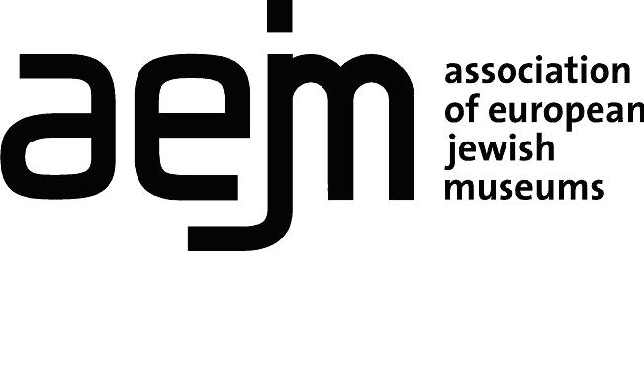

Association of European Jewish Museums
Institutional Associate Membership Application Form (3 pages)

Please use English language and complete both sections of the form

Section 1. Identification of the institution applying for membership

Applying institution |  | Name (in English)
 | Institution
 | Collection
Function
Date of establishment
Mailing address
City |  |  | ZIP code | Country
Telephone
E-mail
Website
Name of the Museum’s director or Name and position of person to whom correspondence should be addressed
Telephone
E-mail
VAT number

The AEJM Bylaws state that Associate Members of the AEJM may only be natural persons or legal entities who can make a substantive contribution to the activities of museums and museum services focusing on the Jewish culture and/or history (article 4.3).
The AEJM Practical Standard Regulations (paragraph 1.4) state that Institutional Associate Members may only be:
- a European museum with a collection or a department devoted to Judaica and Jewish history and with at least one full time staff member working with this collection or at this department
- a Jewish museum not based in Europe but with a particular and explicit relation to European Jewish culture and history and to Jewish museums in Europe
- a Jewish museum or museum service in Europe in the course of establishment

Please provide the following information:

- Is your institution registered as a legal entity/not for profit organisation?

Please attach evidence to confirm this status

- Is your institution an independent museum/collection or part of a parent organisation?

- Name of governing body

- How many Full-Time Equivalent paid staff do you employ (including security and support staff)?

- Please provide a brief description of your collections and activities (1 page)

- Is your museum/collection open to the public? Yes/No

Opening hours:

- Is your institution a member of any other museum associations (eg ICOM)? Please insert details:

- If your institution is not based in Europe, please provide a brief report of your contribution to the field of Jewish museums in Europe (1 page)

- What is your interest in joining AEJM as an associate member?

10. Please provide names and contact details for two references (AEJM members)

1.

2.

Section 2. Acceptance form of AEJM membership conditions

The above institution hereby applies for Institutional Associate Membership of AEJM and undertakes to pay the new members’ registration fee of €100 and the annual membership fee in accordance with the number of Full-time Equivalent (FTE) staff employed, as indicated below:

Categories of Membership

Small institutions (1-5 Full-time Equivalent (FTE) paid staff) 110€ excl. VAT
Larger institutions (more than 5 FTE staff) 225€ excl. VAT

Membership applications will be considered at the Annual General Meeting 2021 of the Association of European Jewish Museums (held in November each year) and should be submitted to aejm@aejm.org, August 15, 2021 at the latest. Applicants will be notified of the assembly decision following the meeting.

The registration and annual fees will be invoiced by AEJM after the new member has been accepted at the Annual General Meeting.

Please complete, date and sign the following declaration
I, , declare to be eligible for associate membership of the European Association of Jewish Museums (AEJM) and wish to become an Associate member of AEJM. My activity does not engage in dealing (i.e. buying and selling for profit) in the field of cultural property and I accept the AEJM regulations as well as the ICOM code of Ethics for Museums
Date Place
Signature
Please send by e-mail to aejm@aejm.org

