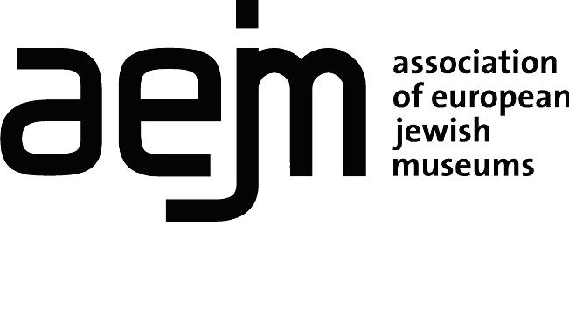

Association of European Jewish Museums
Individual Associate Membership Application Form
(2 pages)

Please use English language and complete both sections of the form

Section 1. Identification of the individual applying for membership

Name
Field(s) of Expertise
Mailing address
City | ZIP code | Country
Telephone
E-mail
Website
VAT number (if applicable)

The AEJM bylaws state that Associate members of the association may only be persons or legal entities who can make a substantive contribution to the activities of museums and museum services focusing on the Jewish culture and/or history (article 4.3).
The AEJM Practical Standard Regulations (paragraph 1.4) state that indiviuals wishing to join the AEJM as Individual Associate Members should either be:
- able to contribute to the activities of the AEJM with their expertise in the field of Judaica, Jewish history and culture, or museology
- working with an organization whose activities are strongly related to and supportive of the aims of the AEJM

Please provide the following information:

- Please provide a brief report of your contribution to the field of Jewish Museums (1 page)

- What is your interest in joining the AEJM as an associate member?

3. Please provide names and contact details for two references (AEJM members)

1.

2.

Section 2. Acceptance form of AEJM membership conditions

The above individual hereby applies for Individual Associate Membership of the AEJM and undertakes to pay the new members’ registration fee of €100 and the annual membership fee, as indicated below.

Category of Membership

Individuals 110€ excl. VAT

Membership applications will be considered at the Annual General Meeting 2021 of the Association of European Jewish Museums (held in November each year) and should be submitted to aejm@aejm.org, August 15, 2021 at the latest. Applicants will be notified of the assembly decision following the meeting.

The registration and annual fees will be invoiced by the AEJM after the new member has been accepted at the Annual General Meeting.

Please complete, date and sign the following declaration
I, , declare to be eligible for associate membership of the European Association of Jewish Museums (AEJM) and wish to become an Associate member of AEJM. My activity does not engage in dealing (i.e. buying and selling for profit) in the field of cultural property and I accept the AEJM regulations as well as the ICOM code of Ethics for Museums
Date Place
Signature
Please send by e-mail to aejm@aejm.org

