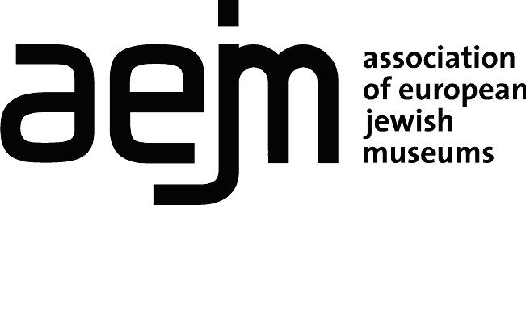
Association of European Jewish Museums
Full Membership Application Form (3 pages)

Please use English language and complete both sections of the form.

Section 1. Identification of the institution applying for membership

Name of the Institution (in English)
Mission statement
Date of establishment
Post address
City | ZIP code | Country
Telephone
E-mail
Institutional Website
Name of the Museum’s director
Name and position of person to whom correspondence should be addressed
Telephone
E-mail
VAT number

Membership applications will be considered at the Annual General meeting of the Association of European Jewish Museums. Please provide the following information:

- Is your institution registered as a legal entity/not for profit organisation?

Please attach evidence to confirm this status.

- Is your institution an independent museum or part of a parent organisation?

- Name of governing body

- How many Full-Time Equivalent paid staff do you employ (including security and support staff)?

- Please provide a brief description of your collections and activities (1 page)

- Is your museum open to the public? Yes/No

Opening hours:

- Is your museum a member of any other museum associations (e.g. ICOM)? Please insert details:

- Please provide names and contact details for two references (AEJM members)

1.

2.

- What is your interest in joining AEJM as an associate member?

Section 2. Acceptance form of AEJM membership conditions

The above institution hereby applies for full membership of the AEJM and undertakes to pay the new members’ registration fee of €250 and the annual membership fee in accordance with the number of Full-time Equivalent (FTE) staff employed, as indicated below.

Categories of Membership

Small (1-5 Full-time Equivalent (FTE) paid staff) 110€ excl. VAT
Medium (6-20 FTE staff) 225€ excl. VAT
Large (21 and more FTE staff) 450€ excl. VAT

Membership applications will be considered at the Annual General Meeting 2021 of the Association of European Jewish Museums (held in November each year) and should be submitted to the aejm@aejm.org August 15, 2021 at the latest. Applicants will be notified of the assembly decision following the meeting.

The registration and annual fees will be invoiced by the AEJM after the new member has been accepted at the Annual General Meeting.

Please complete, date and sign the following declaration
I, , declare that my institution is eligible for full membership of the European Association of Jewish Museums (AEJM) and wishes to become a full member of AEJM. My institution does not engage in dealing (i.e. buying and selling for profit) in the field of cultural property and accepts the AEJM regulations as well as the ICOM code of Ethics for Museums

Date Place
Signature

Name
Please send by e-mail to aejm@aejm.org

